Lab-4 Working with Excel
Name: Kashif Sharma
Student ID:991857768
GitHub Repository link:

INTRODUCTION: In this lab, I learned how to use the **ImportExcel** PowerShell module to work with Excel files without having Microsoft Excel installed. All the work was done from the VS Code terminal on my host machine. I copied the files to my Hyper-V Windows Server (`192.168.1.20`) and ran the commands there through `Enter-PSSession`. This word document report shows my step-by-step commands, screenshots of the output, a short description of each step, and a reflection at the end.
Step 1: Installing Module to work with excel in the terminal
Output: The ImportExcel module is not included in Windows, so my first step was to obtain it from the PowerShell Gallery. After it had been installed, it provided cmdlets such as Import-Excel and Export-Excel that deal directly with the .xlsx format and as a result the server does not need Microsoft Office at all. However, when I executed the same command on the server it failed with a NuGet error since the server has no internet connection. To resolve this, I downloaded the module on my local machine using Save-Module and then copied it to the server's module folder using Copy-Item -ToSession.

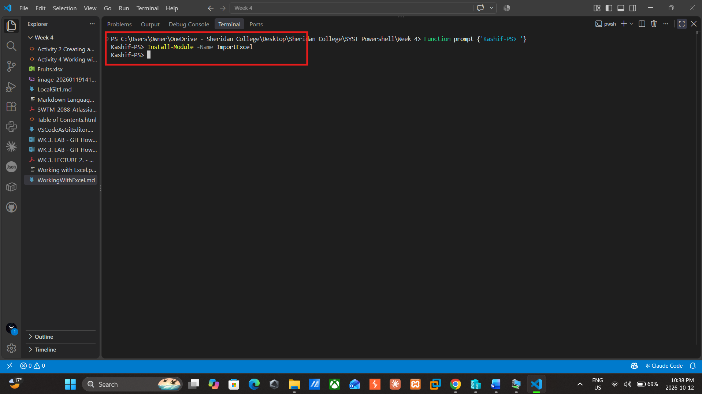

Step 2: Copying Fruits.xlsx file from Host Machine to the Server using command.
Output: First I established a remote session to the server using New-PSSession and stored it in $session. I then placed the copy settings into a hashtable, with Path specifying the location of Fruits.xlsx on my laptop, Destination indicating the folder on the server, and ToSession showing which session the command should be sent through. The command Copy-Item uses splatting, so each item in the hashtable becomes a parameter. When I typed $session it displayed State: Opened, which meant that the connection was working. Test-Path, executed on the server via Invoke-Command, returned True, so the file had been copied successfully.
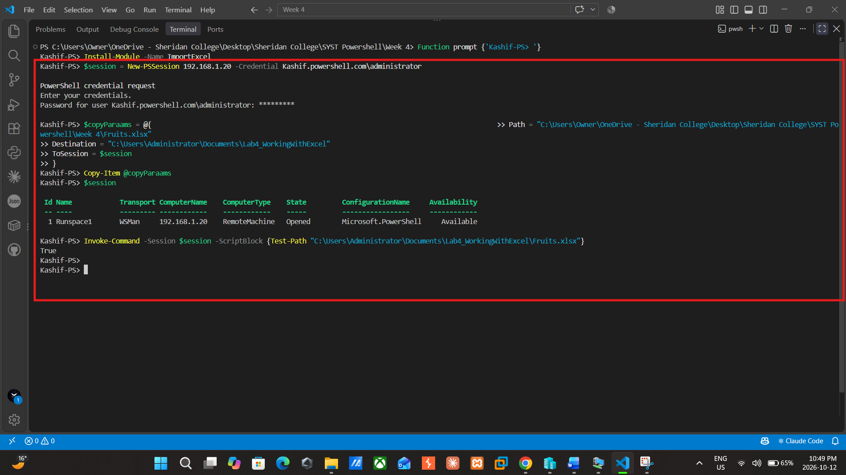

Step 3: Log into server using Enter-PSSession
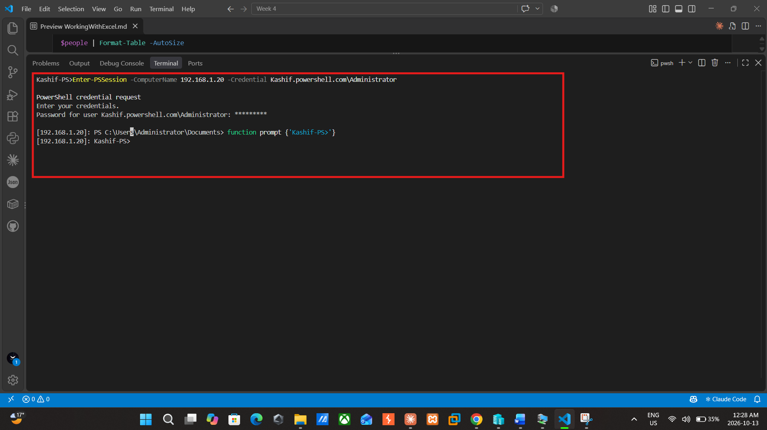

Step 4: Importing Data from a large table of data.
Output: The initial command displayed the six fruits along with their quantities and, since the -OutVariable fruit parameter was used, the same information is also stored in the $fruit variable so that I can use it in the subsequent steps without having to import it once again. When $fruit was piped to Get-Member, it revealed exactly what PowerShell constructed from the spreadsheet: a System.Management.Automation.PSCustomObject for each row, the column headings being converted into two NoteProperty members called Fruits and Quantity. The Equals, GetHashCode, GetType and ToString methods are simply those that every object possesses. It became important later to know the exact names of the properties since the chart references the columns by these names.

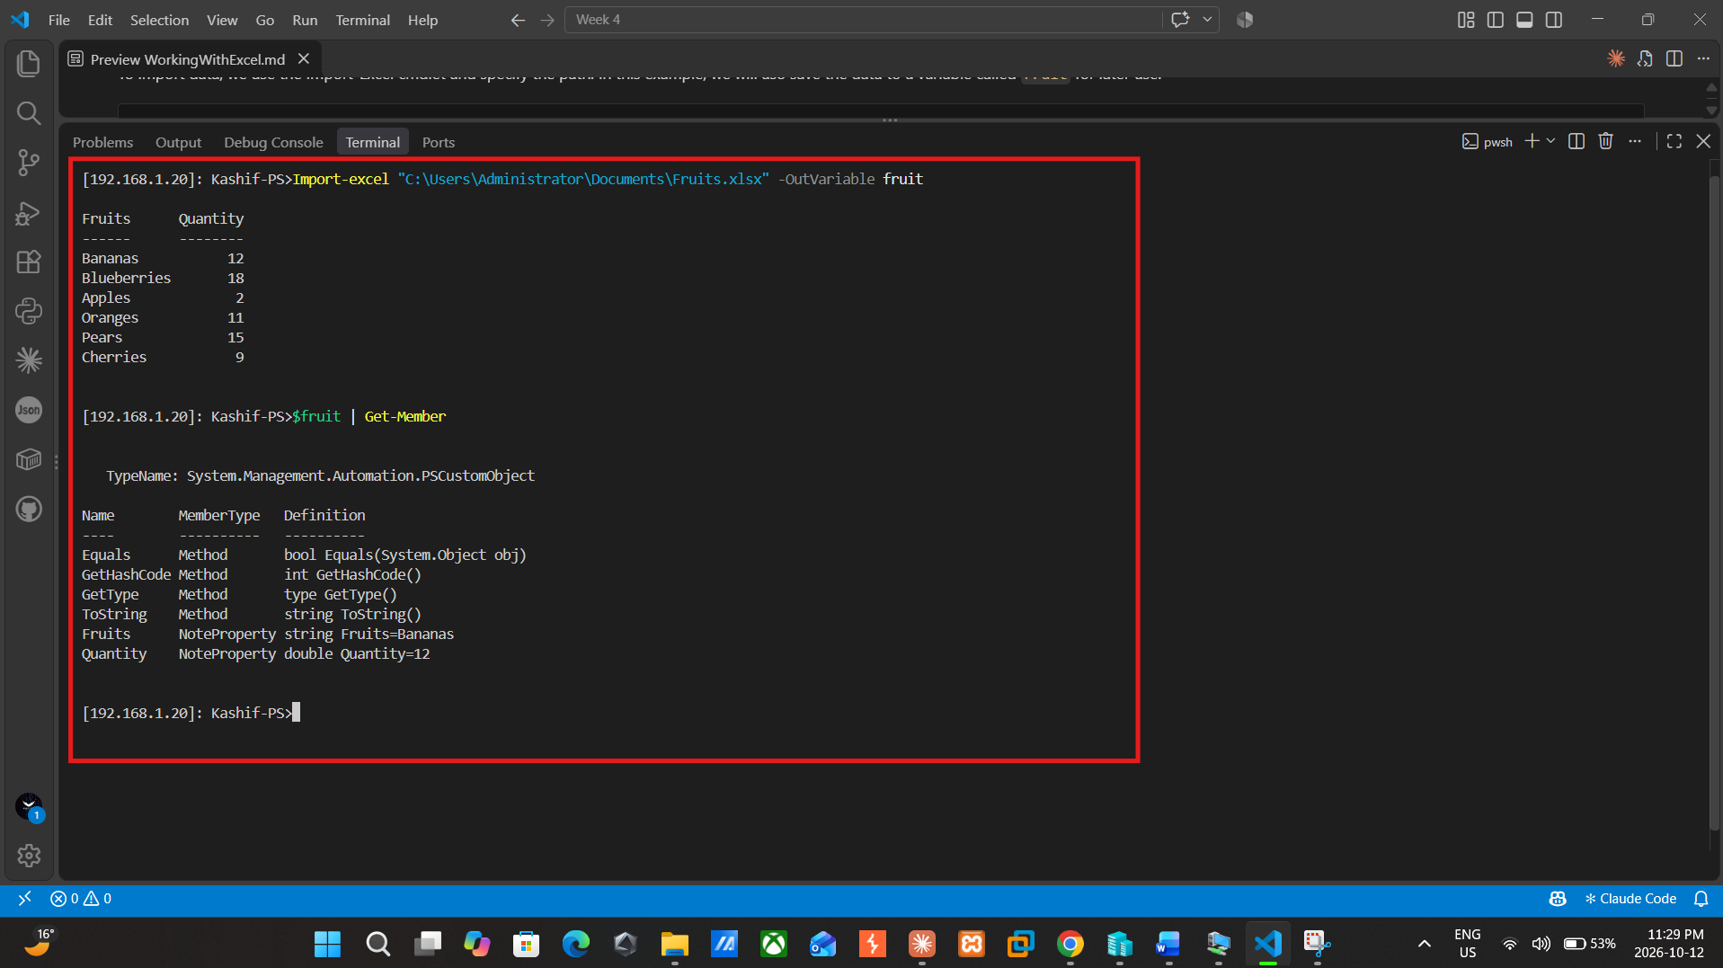

Step 5: Exporting the data to Excel
Output: I ran Get-Process to get all running processes on the server, then I piped to Export-Excel. They were saved to a new file named ProcessInfo.xlsx, on a worksheet named “Processes”. The command didn't produce any output on the screen, a PowerShell way of saying without errors. I did a dir check on the file path just to be sure. It displayed the file ProcessInfo.xlsx in the Documents folder and its size was approximately 40 KB indicating that the file exists and contains data. Microsoft Excel isn’t installed on the server, so the ImportExcel module created the spreadsheet itself.
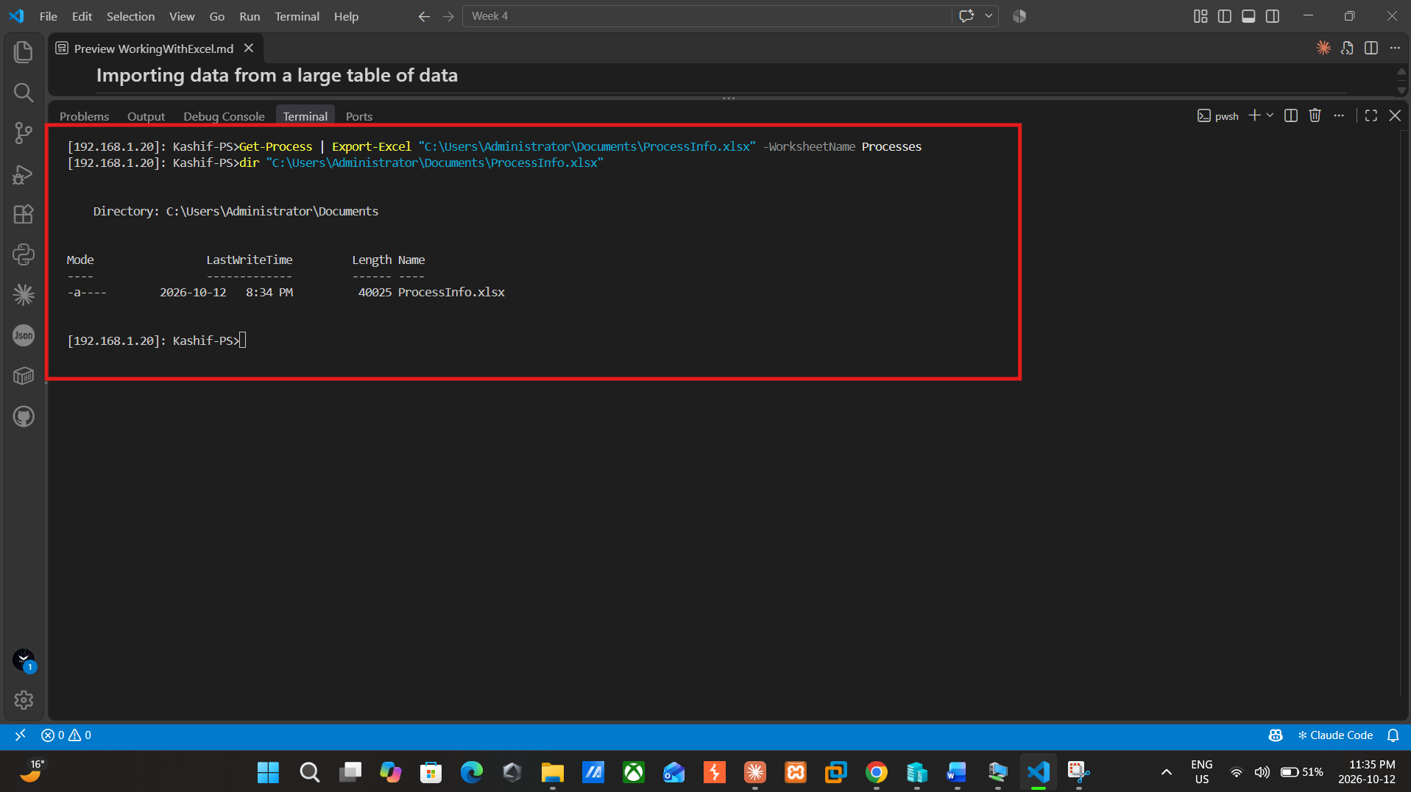

Step 6: Importing data from a large table of data
Output: I ran Get-Process to get all running processes on the server, then I piped to Export-Excel. They were saved to a new file named ProcessInfo.xlsx, on a worksheet named “Processes”. The command didn't produce any output on the screen, a PowerShell way of saying without errors. I did a dir check on the file path just to be sure. It displayed the file ProcessInfo.xlsx in the Documents folder and its size was approximately 40 KB indicating that the file exists and contains data. Microsoft Excel isn’t installed on the server, so the ImportExcel module created the spreadsheet itself.

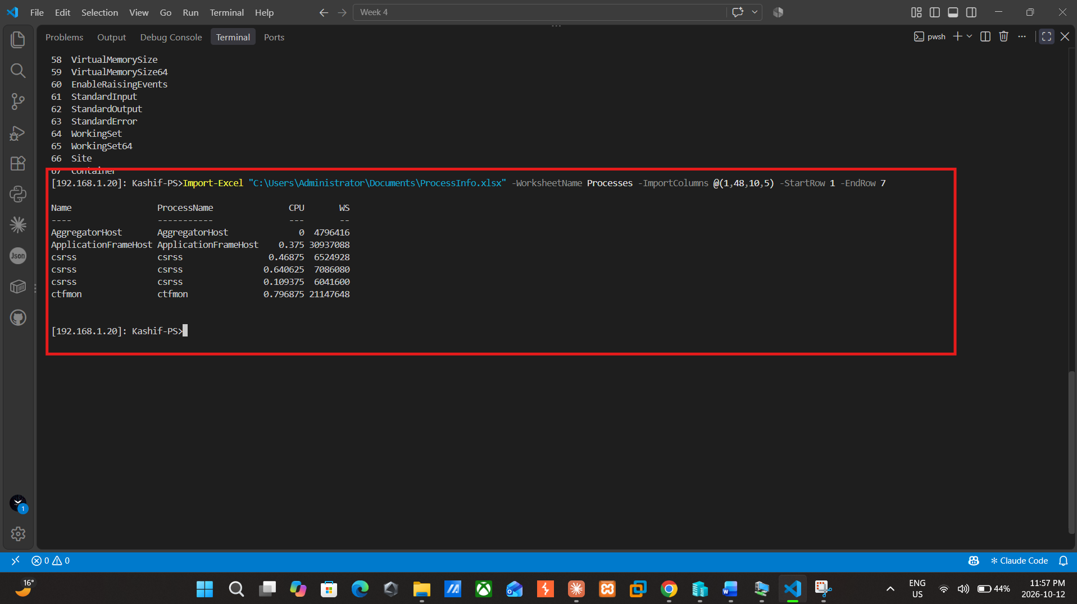

Step 7: Adding data to the existing Spredsheet
Output: My first idea was to create a little table to have four people and their cities. Each [PSCustomObject] block is an object with Name and City properties. The four objects are grouped together inside of an array with the @ syntax and placed in $people. The Format-Table -AutoSize option displays the information in a nice table for inspection prior to export. Afterwards, I exported the people information to the ProcessInfo.xlsx by using Export-Excel. I can use the -Append parameter to append the data to the existing file, and use the -WorksheetName parameter to write the data to the worksheet "People. I could edit the file without -Append and end up losing my Processes worksheet. The Name and City columns have been formatted to be displayed in four rows using Format-Table. If the export command is successful, then there will be no output from it. I then imported the People worksheet (Import-Excel). The four individuals are present in the output; it indicates that the data has been added and can be retrieved.
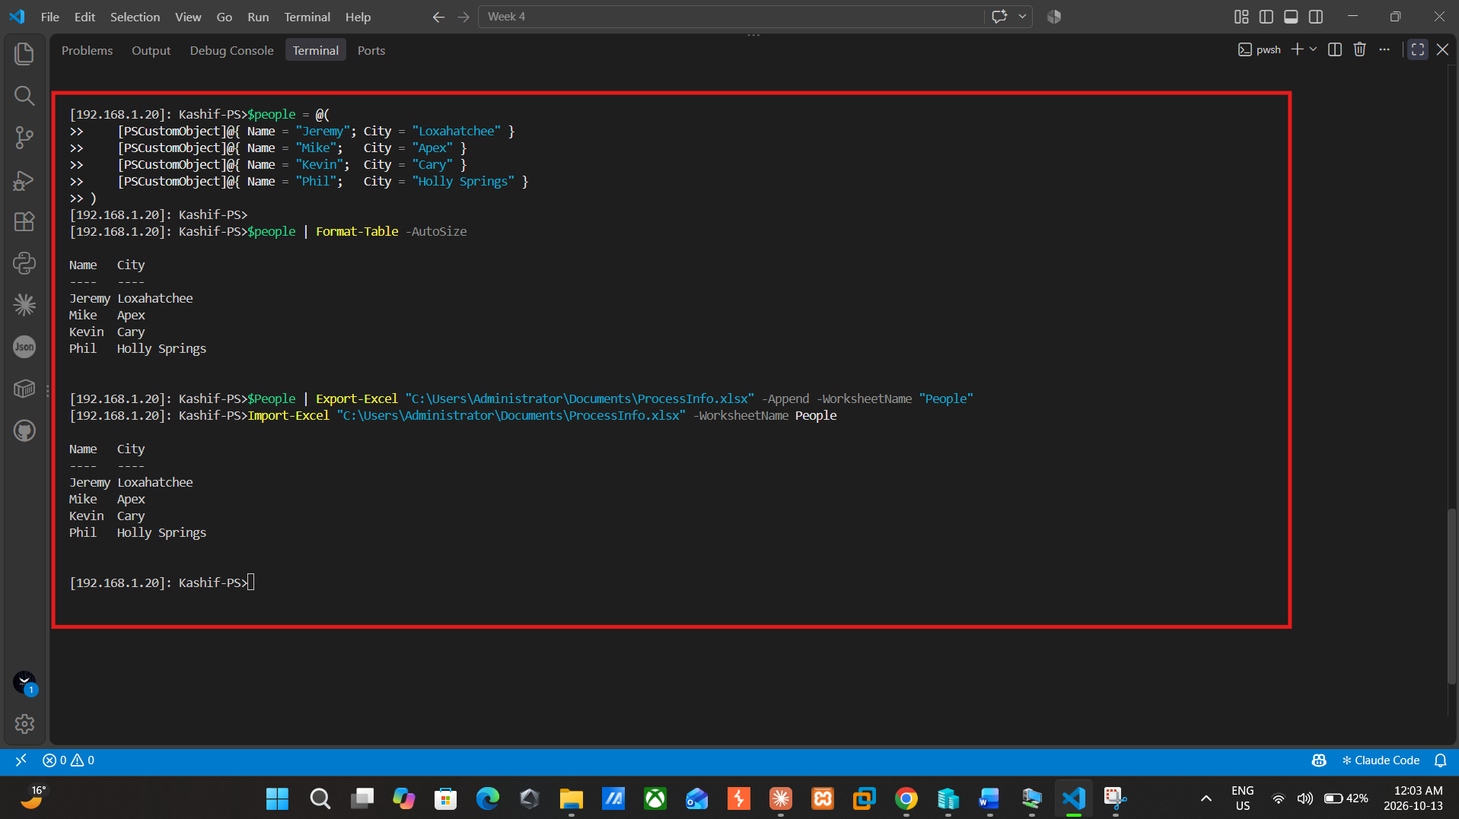

Step 8: Exporting Data with Formatting
Output: For this step I exported the People data in the form of a formatted table rather than as plain rows. The TableStyle Medium16 applies one of Excel's built-in table styles, the Title option adds a heading above the table, and TitleBold makes that heading bold. The data was placed into a new file, ExcelDemo.xlsx, on a tab called PeopleFormatted. The command produced no output and the result of running dir C:\temp showed that ExcelDemo.xlsx had been created with a size of about 3.5 KB, which proves that the formatted file was saved on the server.

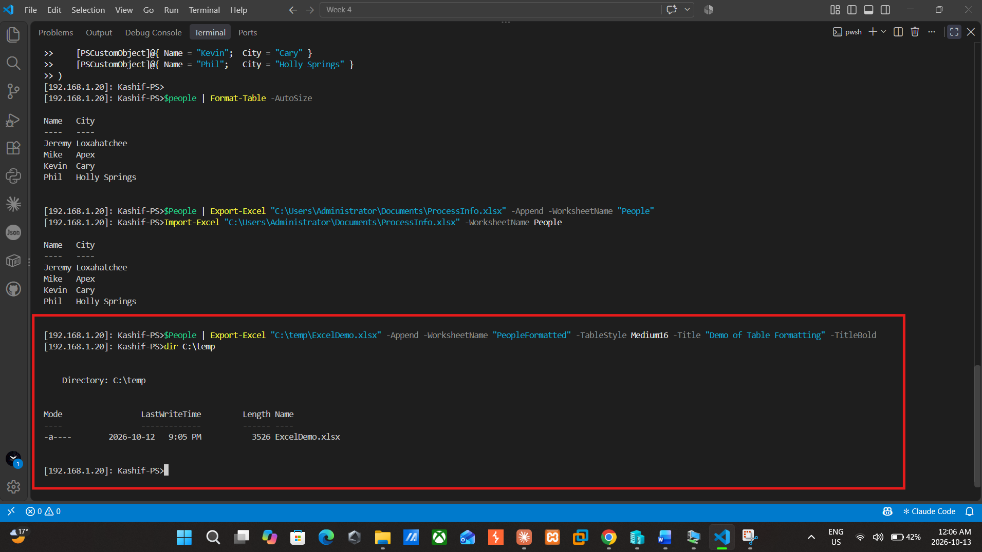

Step 9: Exporting with formatting
Output: Firstly I exported the data again but this time with formatting. I added a new tab called FruitsFormatted to the Fruits.xlsx file which contains the fruits data. -AutoSize changes the column widths to fit the data, -BoldTopRow boldens the header row, -FreezeTopRow leaves the header row visible when scrolling, -AutoFilter adds the filter buttons to the column headers, and -TableName/-TableStyle formats the data as an Excel table. I used -ClearSheet to rewrite the People tab of ProcessInfo.xlsx as a formatted table called PeopleTable. Both commands returned no output so they did their jobs. Then I verified the formatting using Open-ExcelPackage which isn't installed on a server.
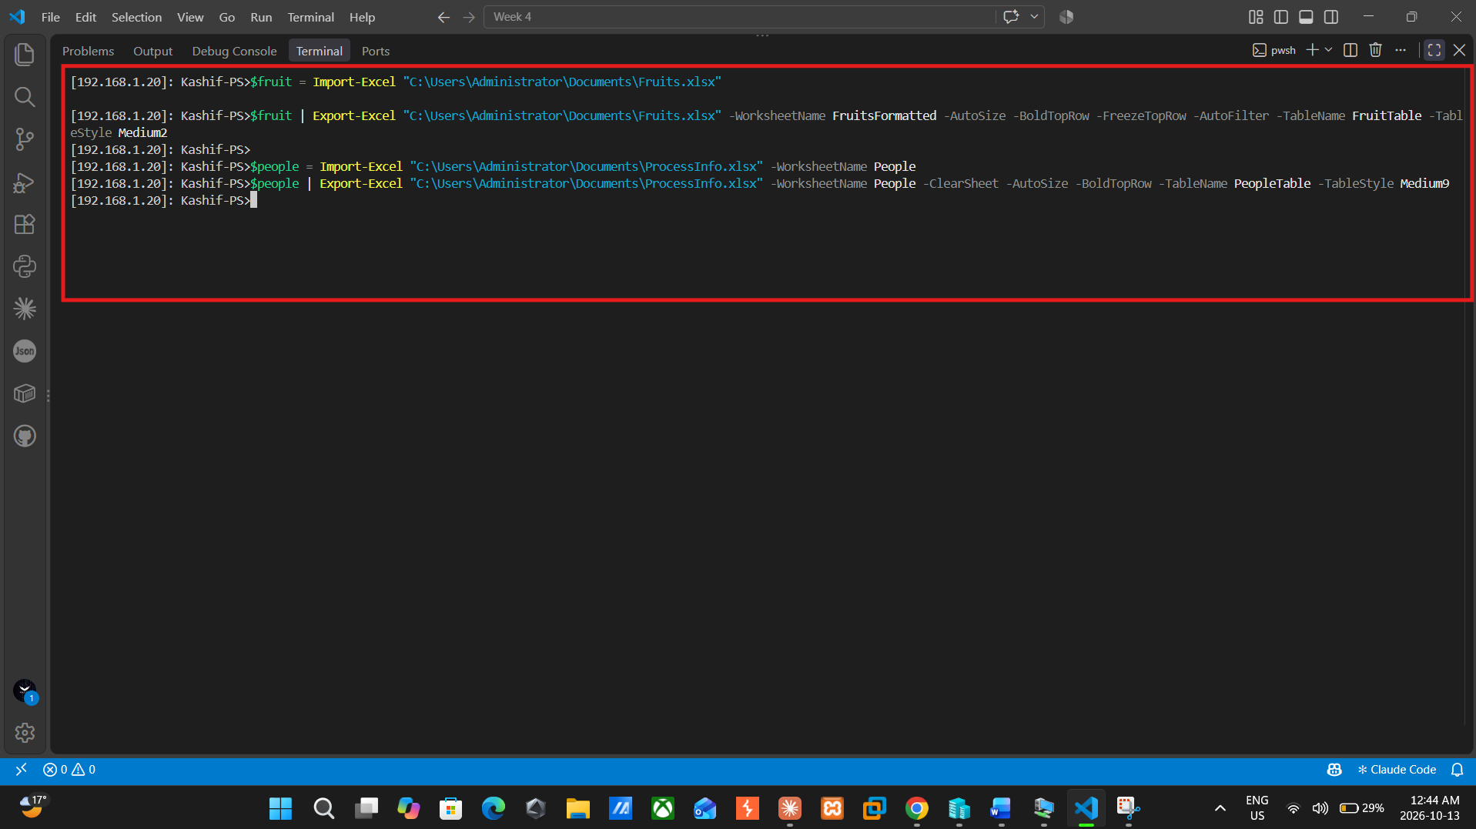

Step 10: Creating a chart
Output: I have set up a column chart using New-ExcelChartDefinition, the fruit names on X axis and quantities on Y axis. I called it Fruit Quantity Overview and gave the legend the name of Total Units. Then I used -Append and -ExcelChartDefinition to export the fruit data, the latter added a new tab called FruitOverviewChart to KashifLab4Report.xlsx, while the former used to have KashifLab4Report.xlsx recognise the columns of Fruits and Quantity from the chart in the new tab. I also created a StaffLocations tab in the same file which has a green table style and bold title. The server didn't have excel on it so I copied it to my laptop to open it. The chart corresponds to the table: Blueberries is the tallest bar with a height of 18 and Apples is the shortest with a height of 2.
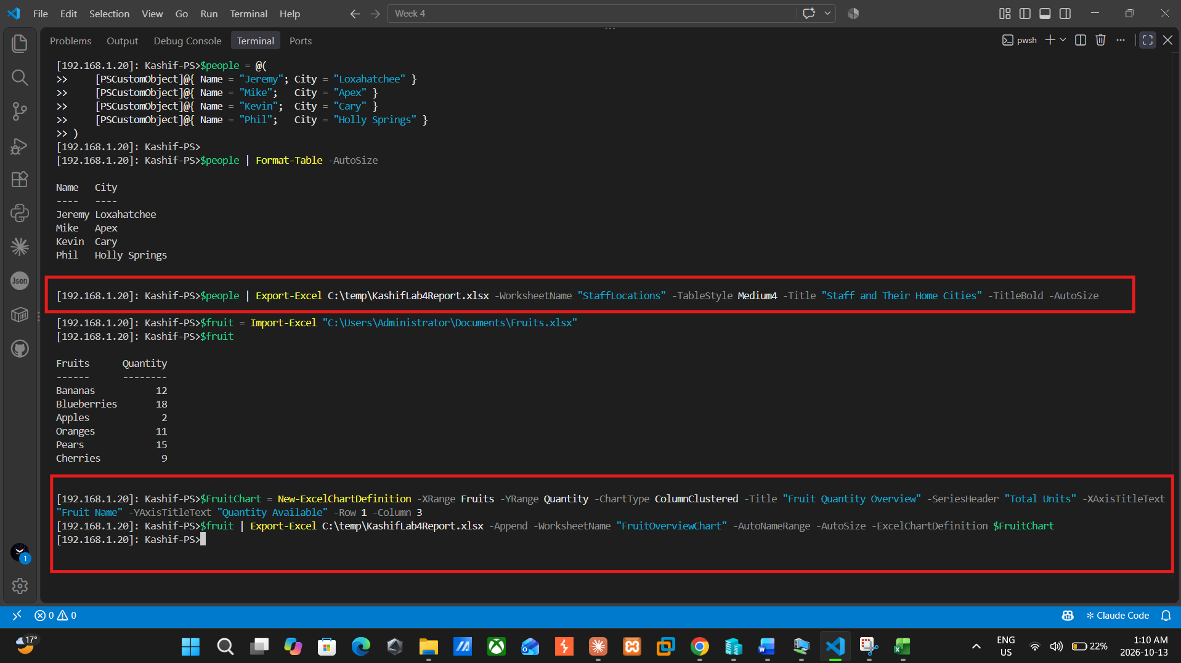
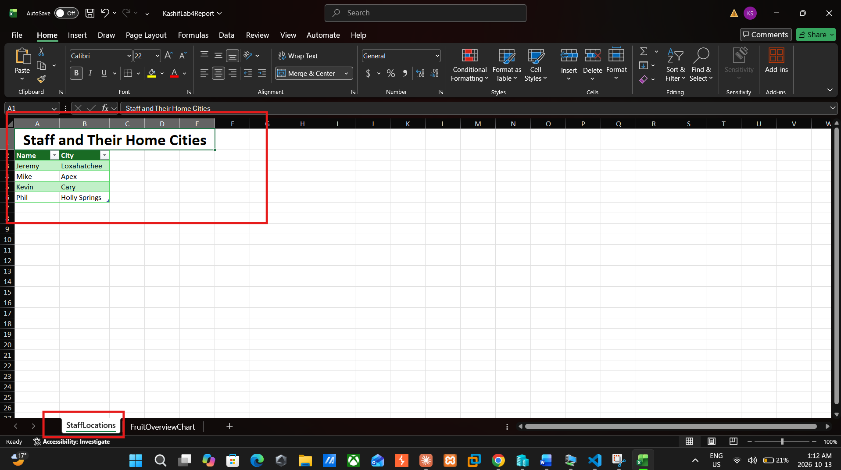
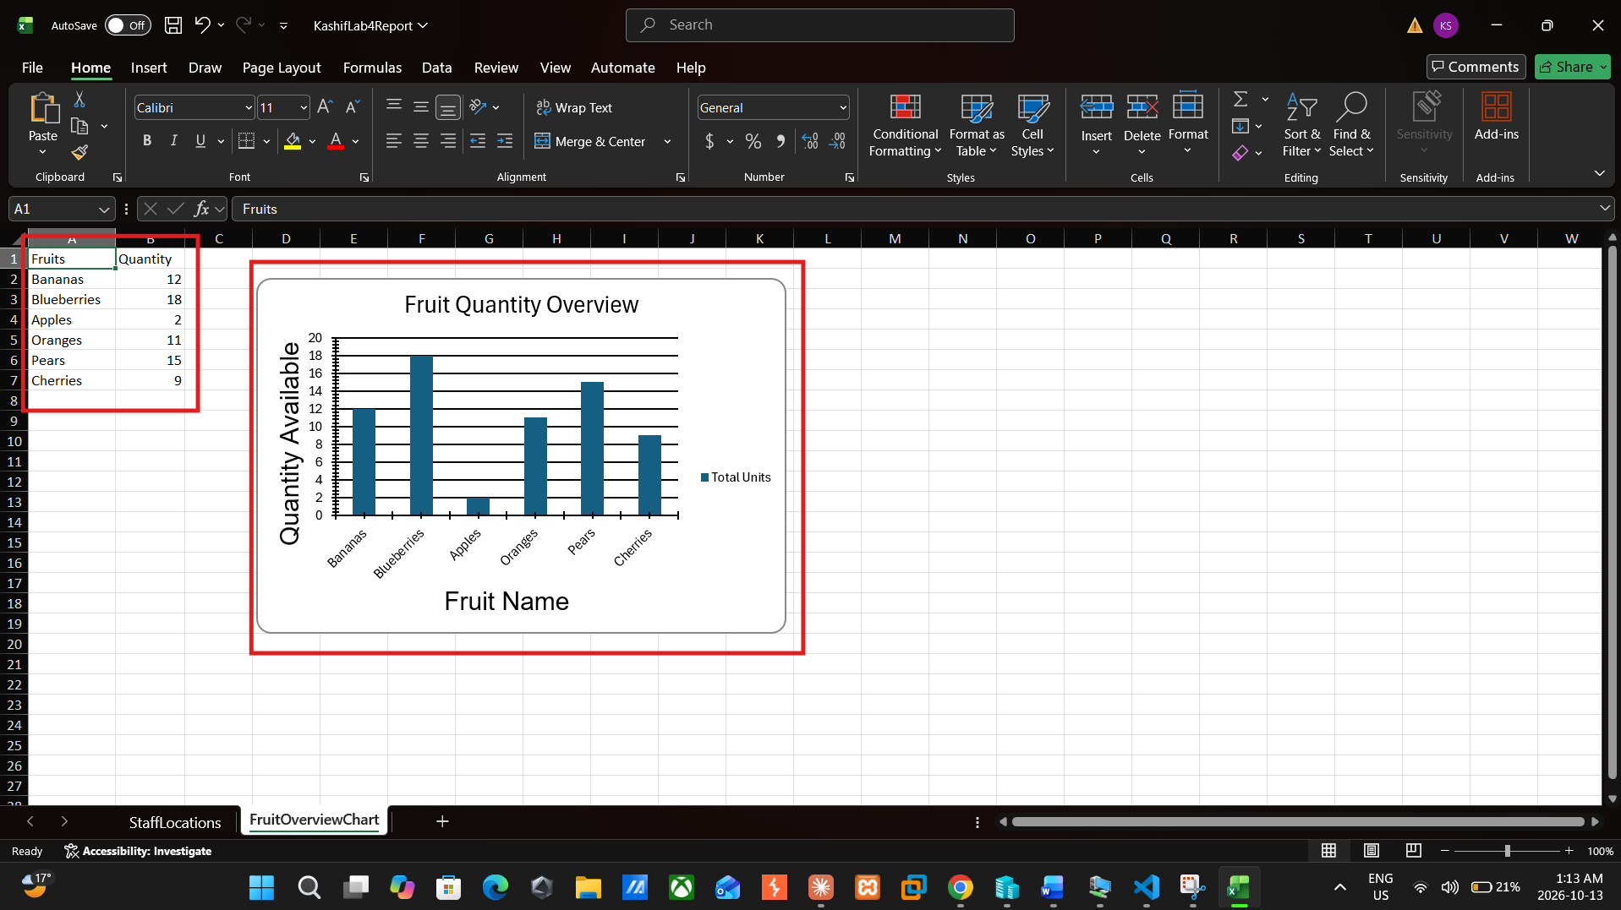

Reflection:
The ImportExcel module is used in this lab to work with excel files from PowerShell without the app of microsoft excel. What was most helpful was learning that Import-Excel converts each row of a spreadsheet into a PSCustomObject, which means that you can use the data in the same way as any other PowerShell output. Export-Excel does the opposite of above: It can take the output of a command, such as Get-Process, and save it directly to a spreadsheet.
The most difficult part for me was from the beginning. I am running Install-Module on the server, and it's failing due to a NuGet error because the server doesn't have internet access. To circumvent this, I saved the module using Save-Module to my laptop and copied the saved module to the inside of the server module folder using Copy-Item -ToSession. That was a lesson that taught me that a module needs to be installed on the machine itself upon which the commands are executed, and not merely on my own computer.
Also I noticed there were a few problems with the lab instructions such as the need to add a space before the @ on import columns and columns 1, 46, 12 and 6 did not match my file. I printed my own column list with this, and I discovered that Name, ProcessName, CPU and WS were columns 1, 48, 10 and 5 on my server. Subsequently, my $people variable was empty and the table export would not work, so I re-entered the data myself. I learned that the chart is not on the People tab, but that it has a separate worksheet as well.
Overall, this lab gave me ideas to always be careful of the output and error messages and not take the instructions for granted because they don't always apply to my environment. They will come in very handy when building automated reports from servers in the future.

